1)

Z = X + Y

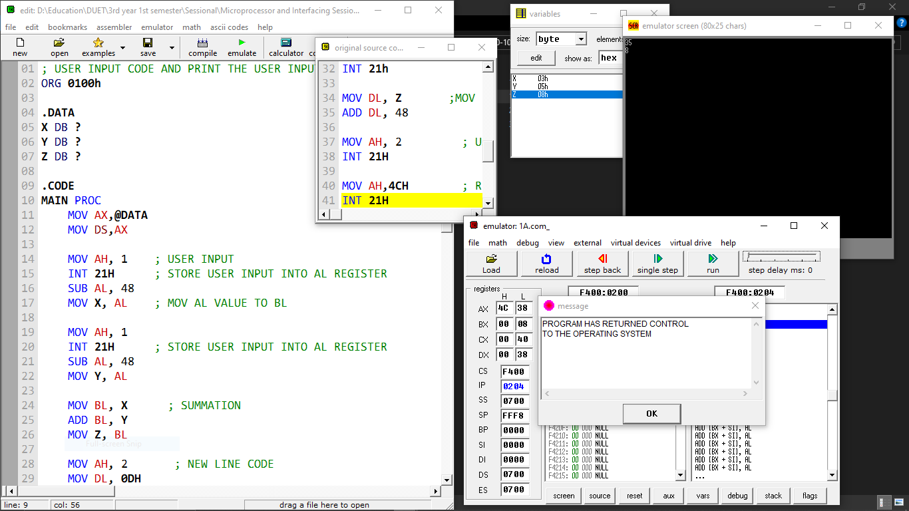Z = X - Y + 1

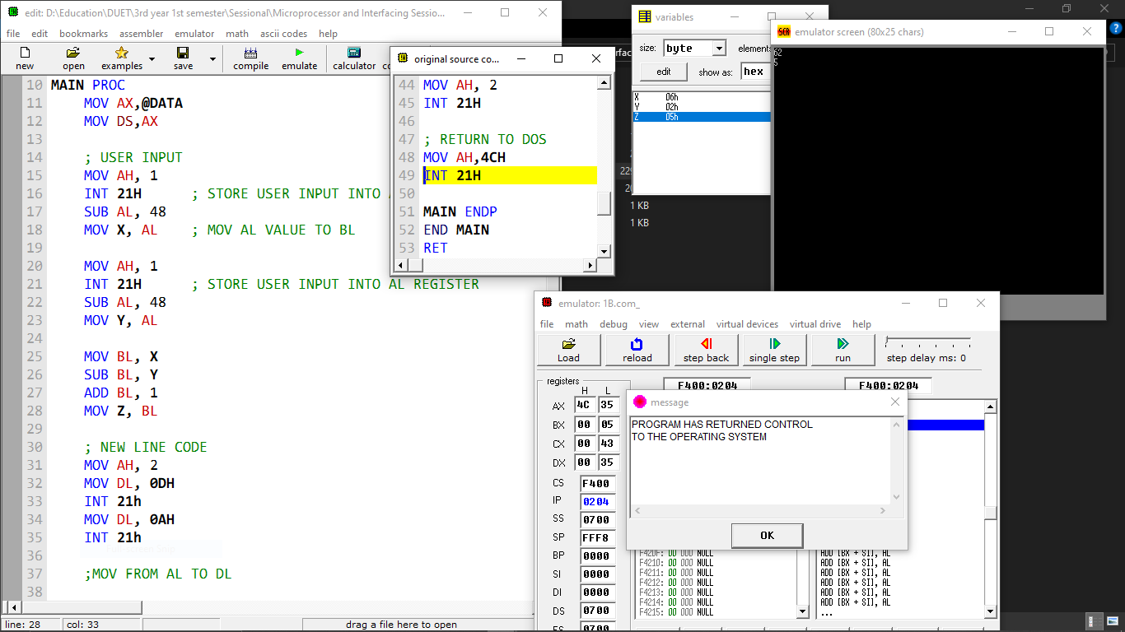

2)

Sample Input / Output:

Input: G Output: g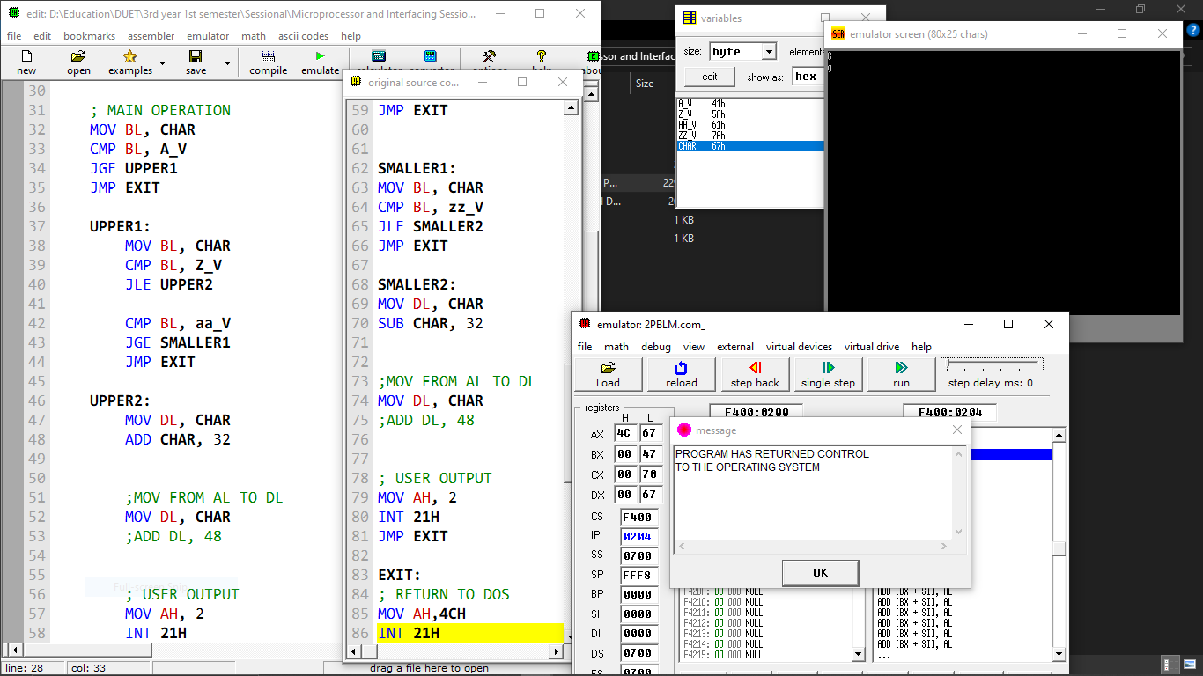

Sample Input / Output:

Input: r Output: R 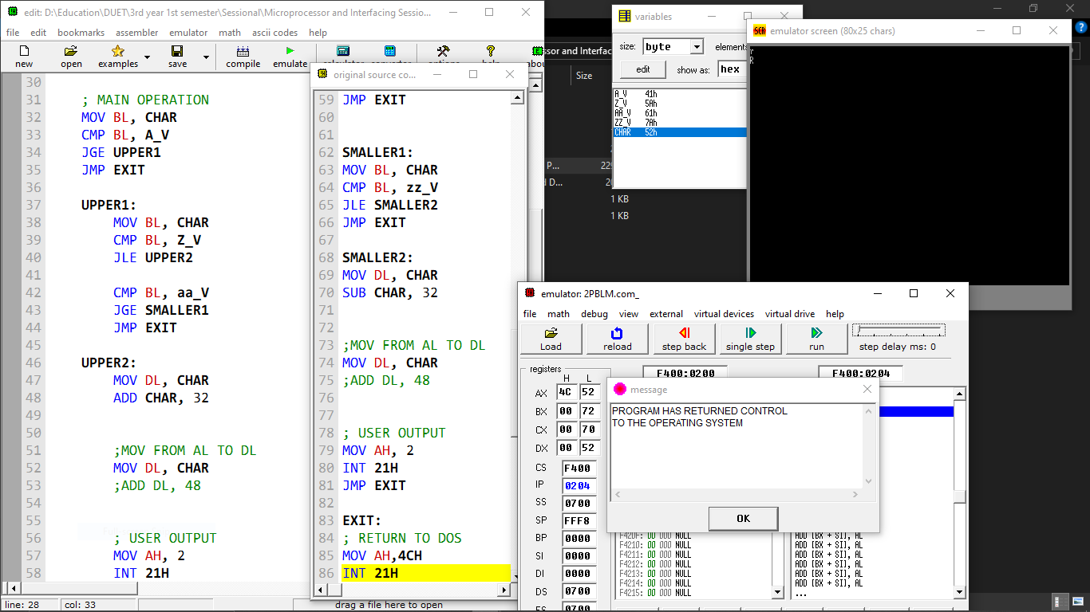

3)

Input: h

Output: IJKLM

GFEDC

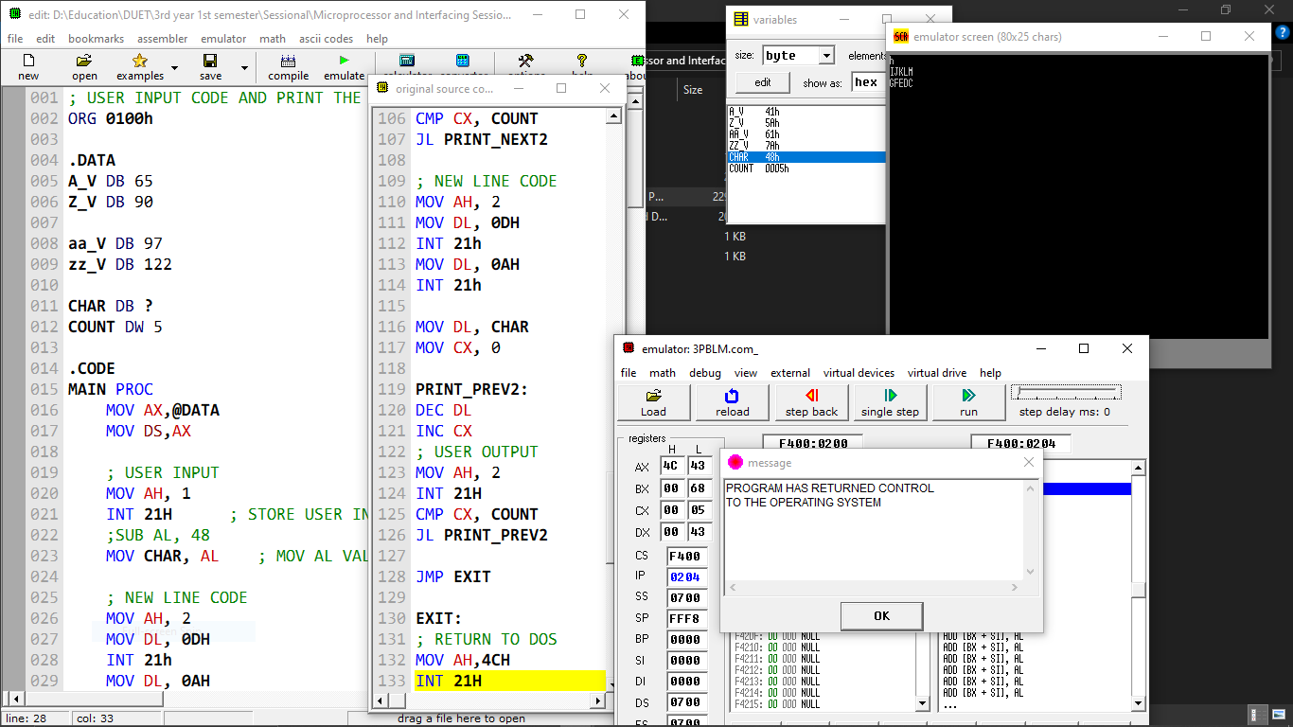

Input: G

Output: hijkl

fedcb 